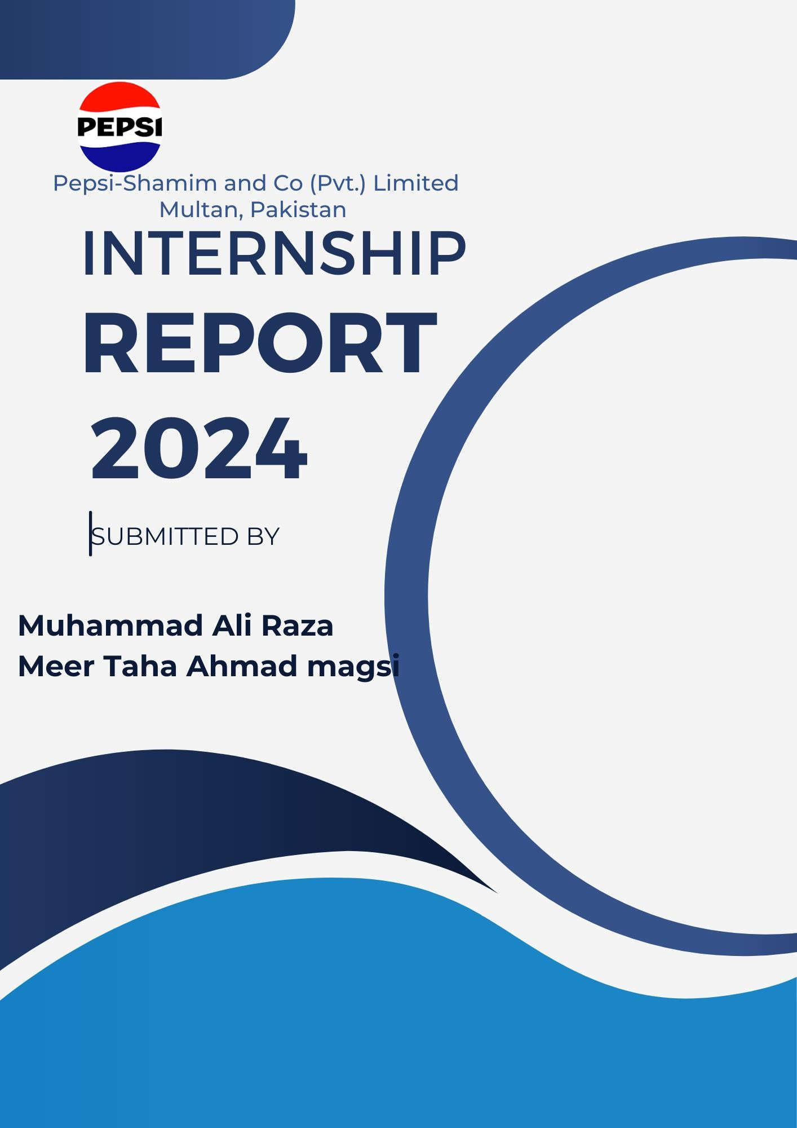

Muhammad Ali Raza
Meer Taha Ahmad Magsi
Khadija Laraib
Ifra

Introduction
This report delivers an extensive evaluation of the boiler systems at Pepsi-Shamim and Co (Pvt.) Limited Multan, focusing on the operational efficiency, environmental impact, and safety of the current systems. Boilers are integral to the beverage production process, making their performance critical to overall operational success. This analysis will provide a detailed review of the two primary boilers, their efficiency in meeting steam demands, and their environmental and safety implications. Additionally, it will explore opportunities for enhancing sustainability through the adoption of renewable energy sources and other eco-friendly practices. The findings aim to align the company's operations with global sustainability trends and promote a more efficient and responsible manufacturing environment.

Boiler #01 - Detailed Speciﬁcations
- Boiler No: WP-554
- Boiler Name: Fire Tube (Wet Back)
- Working Pressure: 150 PSI (Pounds per Square Inch)
- Heating Surface: 1565 Square Feet
- Capacity: 6 Ton/H
- Hydraulic Test Pressure: 275 PSI (Pounds per Square Inch)
- Burner Type: Dual (Natural Gas/Oil)
- Burner Name: SAACKE

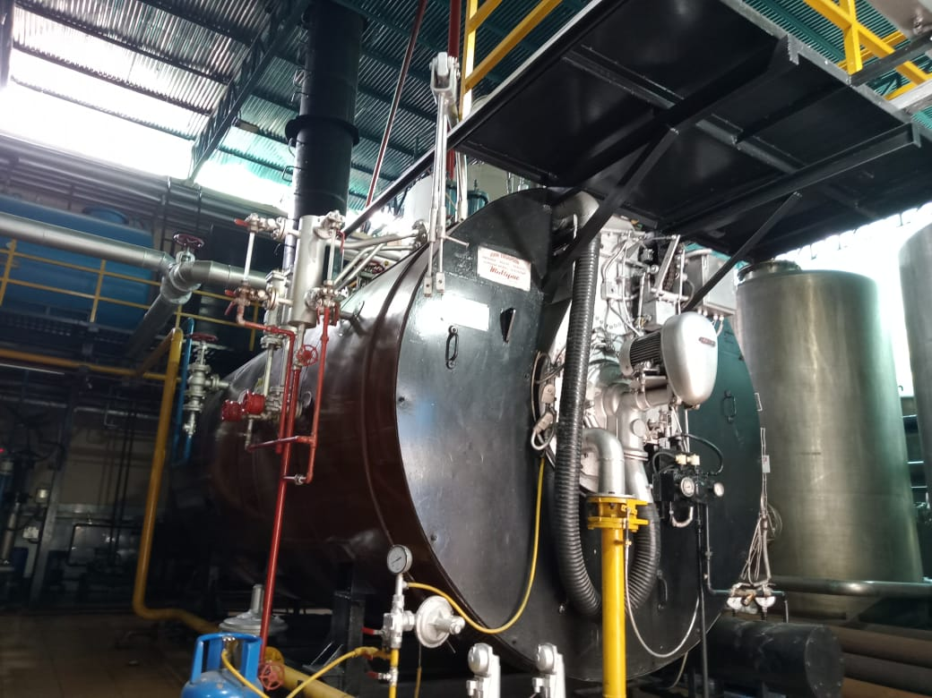
Description:
Figure 1: SAACKE Boiler
Boiler #01:
At Pepsi-Shamim and Co (Pvt.) Limited is a Fire Tube (Wet Back) boiler, which is well-known for its robust design and eﬃcient operation. It has a capacity of 6 Ton/H, making it suitable for the steam needs of various processes within the plant. The dual-fuel burner from SAACKE ensures ﬂexibility in fuel choice, allowing the boiler to operate on either natural gas or oil. This ﬂexibility is crucial for maintaining continuous operations, especially in situations where fuel supply may be inconsistent. The boiler operates at a working pressure of 150 PSI, making it suitable for a wide range of industrial applications, from heating to process steam.

Boiler #02 - Speciﬁcations
- Boiler No: WP-555
- Boiler Name: Fire Tube (Wet Back)
- Working Pressure: 150 PSI
- Heating Surface: 1800 Square Feet
- Capacity: 7 Ton/H
- Hydraulic Test Pressure: 275 PSI
- Burner Type: Dual (Natural Gas/Oil)
- Burner Name: SAACKE

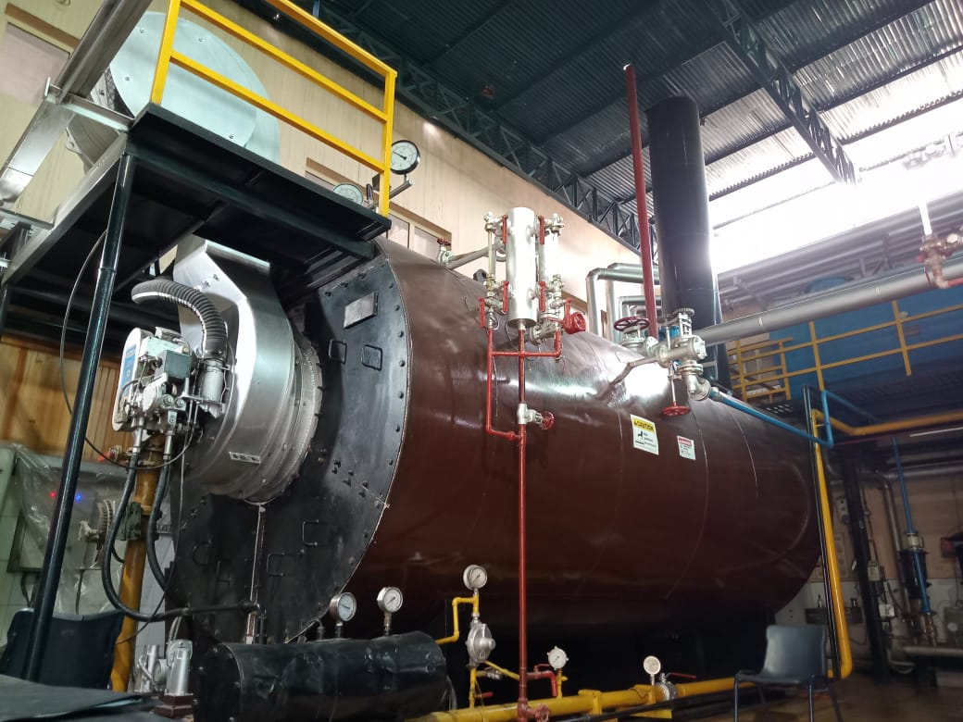
Description:
Figure 2 SAACKE Boiler No.2
Boiler #02, with a capacity of 7 Ton/H, has a slightly larger capacity compared to Boiler #01. It features a larger heating surface of 1800 square feet, which enhances its ability to transfer heat efficiently. Like Boiler #01, Boiler #02 is equipped with a dual-fuel burner, providing operational flexibility. The working pressure of 150 PSI and other operational characteristics indicate that this boiler is designed to meet the high steam demands of the plant, particularly during peak production periods.

Steam Consumption Analysis

Steam is a critical utility in the production processes at Pepsi-Shamim and Co (Pvt.) Limited, and understanding its consumption is essential for optimizing operations and improving energy eﬃciency. Below is an updated and corrected analysis of steam consumption across various machines and production lines:
Sr# | Machine Name | Steam Consumption
1 | Hot Water System | 495 kg/hr
2 | CIP Unit | 600 kg/hr
3 | UHT | 120 kg/hr (during production)
 |  | 300 kg/hr (during CIP)
4 | Straw Applicator | N/A
5 | SMI | N/A
6 | Aseptic Filling Machine | 2.4 kg/hr (during juice line production)
7 | Simonazzi | 700-800 kg/hr (during glass line operation)

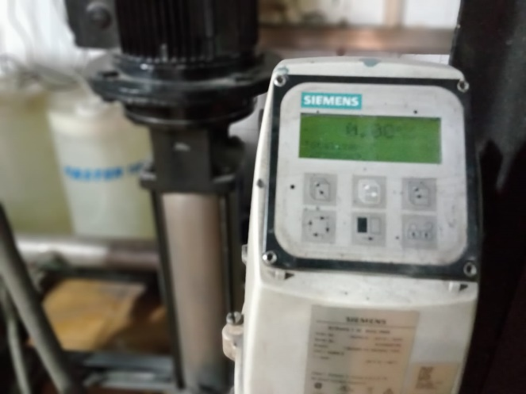
Figure 3: Common Head Flow Meter

Additional Considerations:
Syrup Room: Steam consumption data for the syrup room is not explicitly available, but it is an integral part of the production process. The syrup room is likely to consume signiﬁcant amounts of steam, especially during the preparation and mixing of syrups for various beverages.
Other Production Lines: The plant operates nine production lines, including seven plastic bottle lines, one glass bottle line, and one juice line. Each of these lines has its own steam requirements, especially during cleaning-in-place (CIP) operations, where steam is used to sterilize and clean equipment.

Total Steam Consumption:

On high production days, the total steam consumption across the plant can reach 50-60 tons per day. This includes steam used in the juice line, glass line, and other production lines, as well as in the syrup room.

Actual Steam Production vs. Boiler Capacity:

It is important to note that while the boilers have capacities of 6 Ton/H and 7 Ton/H, the actual steam production is based on the plant's needs. For example, if the demand is only 2.5 Ton/H, the boilers are operated to produce just that amount, despite their higher capacity. This practice helps in

Boiler Eﬃciency Analysis

Boiler eﬃciency is a key performance indicator that reﬂects how well a boiler converts fuel energy into steam. High boiler eﬃciency translates to lower fuel costs and reduced environmental impact. The eﬃciency of the boilers at Pepsi-Shamim and Co (Pvt.) Limited can be evaluated using both direct and indirect methods.

Direct Eﬃciency Calculation

The direct eﬃciency of a boiler can be calculated using the formula:

Boiler Efficiency (%)=$\frac{HEAT OUTPUT}{HEAT Input}$ ​×100
Where:

Heat Output refers to the energy used in generating steam.
Heat Input refers to the energy provided by the fuel.
Assuming the following:

Mass of steam produced: 50,000 kg/day
Enthalpy of steam: 2200 kJ/k
Mass of fuel consumed: 60 tonnes/day
Caloriﬁc value of HFO: 40,000 kJ/kg

Boiler Efficiency =$\frac{50,000×2200}{40,000×60}$× 100 = 45.83%
This simpliﬁed calculation indicates that the boiler is operating at approximately 45.83% eﬃciency, which suggests room for improvement.

Indirect Eﬃciency Calculation (Heat Loss Method)

The indirect method calculates boiler eﬃciency by accounting for various heat losses. These include:

Heat Loss Due to Dry Flue Gas: Sensible heat loss in ﬂue gases.
Heat Loss Due to Moisture in the Fuel: Latent heat loss.
Heat Loss Due to Unburnt Carbon: In ﬂue gases and bottom ash.
Radiation Losses: Heat lost through radiation and convection from the boiler's surface.

The formula for indirect eﬃciency is:

Boiler Efficiency = 100% − Total Heat Losses
This method provides a more detailed understanding of where energy losses occur and how they can be mitigated.

Environmental Impact Assessment
The environmental impact of boiler operations at Pepsi-Shamim and Co (Pvt.) Limited is closely linked to the type of fuel used, the eﬃciency of combustion, and the management of emissions. Historically, the plant operated on diesel, but has since transitioned to Heavy Furnace Oil (HFO). While this shift has reduced fuel costs, it also poses challenges related to emissions and environmental sustainability.

Key Environmental Considerations:

Carbon Emissions: HFO combustion results in signiﬁcant CO2 emissions. Reducing these emissions is critical for the plant’s sustainability goals.
Air Pollutants: The burning of HFO produces sulfur oxides (SOx) and nitrogen oxides (NOx), which contribute to air pollution and acid rain. These pollutants can be mitigated by installing ﬂue gas desulfurization (FGD) systems and selective catalytic reduction (SCR) units.
Water Pollution: Boiler blowdown and other wastewater streams need proper treatment to prevent contamination of local water bodies.

Environmental Recommendations:

  - Biogas Integration: Biogas is a renewable energy source that can be produced from organic waste. Integrating biogas as a supplementary fuel for the boilers can signiﬁcantly reduce carbon emissions and reliance on fossil fuels.
  - Renewable Energy Transition: Gradually transition to cleaner fuels such as natural gas or biofuels. These fuels have a lower environmental impact compared to HFO and are more sustainable in the long term.
  - Emission Control: Invest in advanced emission control technologies to reduce SOx, NOx, and particulate matter emissions. This includes ﬂue gas desulfurization, selective catalytic reduction, and electrostatic precipitators.
  - Sustainability Certiﬁcations: Pursue sustainability certiﬁcations such as ISO 14001 for environmental management and ISO 50001 for energy management. These certiﬁcations will demonstrate the company’s commitment to environmental stewardship.

Safety and Operational Recommendations
Safety is paramount in boiler operations due to the high pressures and temperatures involved. Ensuring that boilers are operated safely and eﬃciently can prevent accidents and improve overall plant performance.

Regular Safety Audits:

Conduct comprehensive safety audits at regular intervals to identify and address potential hazards. This includes checking pressure relief valves, safety interlocks, and emergency shutdown systems.
Ensure that all safety devices are functioning correctly and are calibrated according to the manufacturer’s speciﬁcations.

Operator Training:
Provide continuous training for boiler operators to ensure they are well-versed in the latest safety protocols and operational procedures. Training should cover topics such as emergency response, routine maintenance, and energy eﬃciency practices.
Encourage certiﬁcation programs for operators, such as the Boiler Operator Certiﬁcation, to enhance their skills and knowledge.

Safety Protocols:
Implement strict safety protocols for boiler operation, including lockout/tagout procedures during maintenance, regular inspection of pressure vessels, and adherence to operational limits. Establish clear guidelines for handling emergencies, such as boiler failures or fuel supply disruptions, to minimize risks to personnel and equipment.

Maintenance Best Practices:

Establish a preventive maintenance schedule for all boiler components, including the burner, pressure vessels, heat exchangers, and controls. This proactive approach helps in identifying issues before they lead to breakdowns, ensuring continuous and safe operation.
Utilize predictive maintenance tools such as thermal imaging and vibration analysis to detect early signs of wear and tear. These technologies can prevent unexpected failures and extend the lifespan of boiler components.

Contingency Planning:

Develop and regularly update contingency plans to deal with boiler failures, fuel supply disruptions, and other emergencies. The plan should include backup systems, a spare parts inventory, and emergency response teams ready to act in case of an incident.

Energy Eﬃciency Enhancements:

Install economizers to recover waste heat from ﬂue gases. The recovered heat can be used to preheat boiler feedwater, reducing fuel consumption and improving overall boiler eﬃciency. Optimize the boiler’s combustion process by using oxygen trim controls. These controls automatically adjust the air-to-fuel ratio to ensure complete combustion, minimizing excess air that can lead to energy losses.

Flexible Boiler Operation:

Operate boilers based on actual steam demand rather than their full capacity. For example, if the demand is only 2.5 tons of steam per hour, the boilers should be adjusted to produce only that amount, even if they have a capacity of 6 or 7 tons per hour. This practice reduces fuel consumption, lowers operational costs, and minimizes wear on the equipment.

Boiler Eﬃciency Improvement Strategies
Improving boiler eﬃciency is crucial for reducing fuel costs, minimizing environmental impact, and ensuring the long-term sustainability of operations. The following strategies are recommended to enhance the eﬃciency of the boilers at Pepsi-Shamim and Co (Pvt.) Limited:

Combustion Optimization:

Use a combustion analyzer to regularly monitor the boiler’s combustion eﬃciency. Adjust the fuel-to-air ratio to ensure optimal combustion, thereby reducing excess air and unburned fuel losses.
Consider installing a ﬂue gas analyzer that continuously monitors the composition of ﬂue gases. This will help in ﬁne-tuning the combustion process and identifying any ineﬃciencies.

Feedwater Treatment:

Ensure that feedwater is properly treated to remove impurities such as dissolved gases, hardness, and silica. These impurities can cause scale formation, reducing heat transfer eﬃciency and increasing fuel consumption.
Implement a deaerator to remove oxygen from the feedwater, preventing corrosion in the boiler and extending its lifespan.

Insulation and Heat Recovery:

Improve insulation on steam pipes, boiler surfaces, and hot water tanks to reduce heat losses. This will help in maintaining steam pressure and temperature, reducing the need for additional fuel.
Install heat recovery systems such as blowdown heat exchangers to capture and reuse the heat from boiler blowdown. This recovered heat can be used to preheat feedwater or provide heat for other processes.

Automated Control Systems:

Upgrade to automated boiler control systems that optimize the operation of the boiler based on real-time data. These systems can adjust fuel ﬂow, air supply, and feedwater ﬂow to maintain optimal eﬃciency.
Use predictive analytics to forecast steam demand and adjust boiler operations accordingly, minimizing energy wastage.

Conclusion and Future Outlook
This comprehensive report has provided an in-depth analysis of the boiler systems at Pepsi-Shamim and Co (Pvt.) Limited Multan, highlighting key areas for improvement in eﬃciency, safety, and environmental sustainability. By implementing the recommendations outlined in this report, the company can achieve signiﬁcant cost savings, reduce its carbon footprint, and enhance the safety of its operations.
Pepsi-Shamim and Co (Pvt.) Limited has already taken important steps by adjusting boiler operations based on actual steam demand, which is a commendable practice that aligns with energy conservation goals. However, there is still signiﬁcant potential to further optimize boiler eﬃciency, improve safety protocols, and reduce environmental impact.
The future of boiler operations at Pepsi-Shamim and Co (Pvt.) Limited lies in embracing new technologies and sustainable practices. The transition to renewable energy sources such as biogas, combined with advanced emission control systems, will position the company as a leader in environmental stewardship within the beverage industry. Additionally, ongoing training and certiﬁcation programs for boiler operators will ensure that the company maintains the highest standards of safety and eﬃciency.
As the global focus on sustainability continues to grow, Pepsi-Shamim and Co (Pvt.) Limited has the opportunity to lead by example, setting new benchmarks for operational excellence and environmental responsibility in the industry. Implementing these recommendations will not only improve the plant's operational eﬃciency but also contribute to a greener, more sustainable future.

